Analysis of Prompting Strategies for Coding
COMP7607 Natural Language Processing-Assignment 2

1 Introduction
Large language models (LLMs) have achieved strong performance on code generation benchmarks such as HumanEval. However, their behavior is highly sensitive to prompt design and inference strategy. In practice, developers often rely on ad-hoc prompt engineering or multi-step “self-correction” pipelines, while the systematic effects of these design choices remain under-explored.
In this report, I study how different prompt factors and inference methods influence functional correctness on HumanEval. Concretely, I analyze four prompt dimensions—quality, complexity, number of demonstrations, and prompt diversity—under two inference methods:
- a baseline method that generates a single solution directly from the prompt;
- a combine method that augments baseline generation with self-refinement and CodeT-style repair using unit-test feedback.
This leads to two main research questions (RQ):
- RQ1: How do prompt quality, complexity, number of demonstrations and diversity affect code generation accuracy for the baseline method?
- RQ2: Does the combine method consistently improve over the baseline across these prompt settings, and in which regimes are the gains most significant or limited?
By answering these questions, I aim to provide concise, concrete insights into how to design prompts and correction pipelines for reliable LLM-based code generation.

2 Methods and Experimental Setup

2.1 Task and Dataset
All experiments are conducted on the HumanEval benchmark. Each task provides a Python function signature, a natural-language docstring and a hidden unit-test suite; the model must generate the function body so that it passes all tests.
I evaluate on 80 HumanEval tasks (the first 80 entries in HumanEval.jsonl). For each task, the model produces a single candidate solution and I measure pass@1 functional correctness by executing the hidden tests.

2.2 Models and Inference Methods

Baseline method
The baseline method uses a single LLM (Qwen-3 8B in my implementation) accessed via an API. For each HumanEval task, I construct a prompt that describes the problem and instructs the model to output only a valid Python implementation of the target function. The model then generates one completion with fixed decoding parameters.
Generated samples are stored by main_generate_baseline.py. The script evaluate_functional_correctness.py runs each sample against the official tests and records metrics such as pass@1 accuracy, average execution time and token usage.

Combine method (Self-Refine + CodeT-style repair)
The combine method uses the same underlying model but changes the inference pipeline:
- Initial generation. The model first produces a candidate solution using exactly the same prompt as the baseline.
- Test feedback. The candidate is executed against the unit tests; failing assertions and error messages are collected.
- Repair loop. The model is called again with a repair prompt that includes the current code and the test feedback, asking it to revise the implementation. This self-refine / repair step is repeated for a fixed number of iterations.
This pipeline is implemented in method_combine.py. Evaluation is handled by evaluate_combine_functional_correctness.py, which mirrors the baseline evaluator but writes results into dedicated folders for the combine method. Because both methods share the same model and nearly the same default prompt format, differences in performance can be attributed mainly to the inference strategy.

2.3 Prompt Design and Experimental Conditions
To study prompt factors, I define four experimental dimensions. Each configuration is realised through command-line arguments (--exp_family, --condition, --num_demos, --diversity_mode) and is run for both baseline and combine on the same 80 tasks.
- Prompt quality (exp_family = quality)
  - clean: well-written description and correct demo code.
  - wrong_demo: includes an intentionally incorrect example solution.
  - irrelevant_demo: includes a correct but irrelevant example for a different task.
  - bad_instruction: adds misleading natural-language instructions.
- Prompt complexity (exp_family = complexity)
  - simple: heavily simplified description with many details removed.
  - original: the standard HumanEval-style description (used as default).
  - detailed: an enriched description with extra constraints and edge cases.
- Number of demonstrations (exp_family = num_demos)
  - k0, k1, k2, k4: 0, 1, 2 or 4 in-context examples (problem plus canonical solution) preceding the target task.
- Prompt diversity (exp_family = diversity)
  - low: a fixed prompt template for all tasks.
  - high: templates sampled from a small pool of paraphrased variants, increasing lexical and structural diversity.

2.4 Hyper-parameters
For all experiments, I used the same base model and API configuration unless otherwise stated. The underlying model is Qwen3-8B, accessed through a DashScope-compatible chat-completions API. The key generation and evaluation hyper-parameters are summarised in Table 1.
Table 1: Main hyper-parameters for baseline and combine methods.
Category | Hyper-parameter | Value
Model & API | Model name | qwen3-8b
Dataset & sampling | HumanEval subset size | 80 tasks
Dataset & sampling | max_samples | 80
Dataset & sampling | Parallel workers | 10
Baseline generation | Decoding temperature | 1
Baseline generation | thinking_mode | disabled
Combine generation | Self-Refine steps (k_sr) | 2
Combine generation | Repair steps (repair_per) | 2
Combine generation | SR temperature (temperature_sr) | 0.7
Combine generation | Repair temperature (temperature_func) | 0.7
All prompt-condition parameters (exp_family, condition, num_demos, diversity_mode) are kept identical between baseline and combine runs for fair comparison. When I report “default” results, I refer to the setting exp_family = none, with the original HumanEval description, zero demonstrations (k = 0) and low diversity.

3 Baseline Results: Effect of Prompt Design

3.1 Overall Baseline Performance
Under the default prompt (original complexity, clean quality, k = 0, low diversity), the baseline method achieves 86.25% pass@1 accuracy on 80 tasks, i.e. 69/80 problems solved. The average execution time per sample is 0.48 s, with 169 prompt tokens and 53 completion tokens on average. This configuration serves as the reference line for all baseline prompt experiments.
Table 2: Default baseline performance on 80 HumanEval tasks
Metric | Value
Tasks solved | 69 / 80 (86.25%)
Pass@1 accuracy (%) | 86.25
Average exec time per sample (s) | 0.48
Average prompt tokens | 169
Average completion tokens | 53

3.2 Prompt Quality (Baseline)
Figure 1 visualises baseline pass@1 accuracy under different prompt quality conditions. For prompt quality, the baseline accuracy is:
- clean: 87.5%
- wrong_demo: 92.5%
- irrelevant_demo: 87.5%
- bad_instruction: 93.75%
Figure 1: Baseline accuracy across prompt quality conditions
(clean, wrong_demo, irrelevant_demo, bad_instruction).
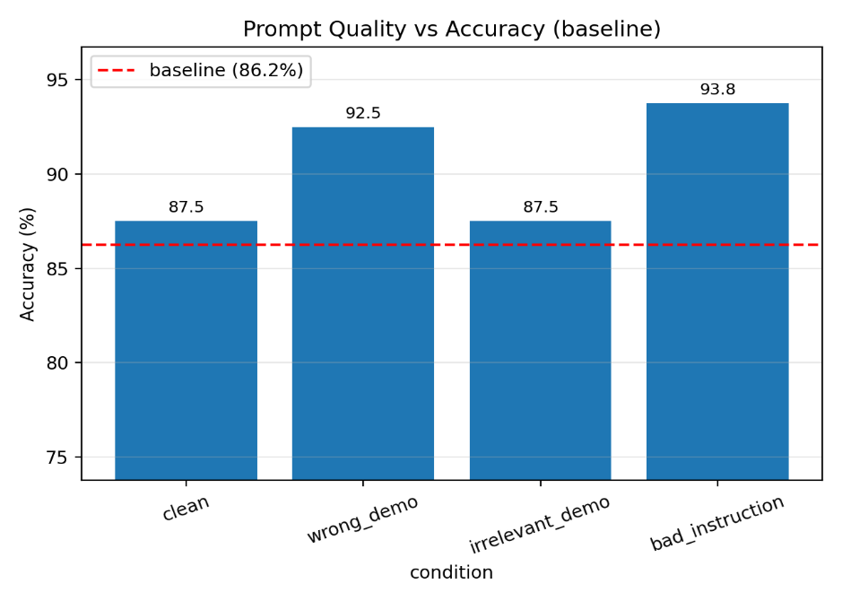
Overall, as shown in Figure 1, the model is surprisingly robust to noisy or misleading demonstrations: accuracy stays within a single-digit margin (around 5–6 percentage points) of the clean condition. Wrong and irrelevant demos slightly increase accuracy, which suggests that the model often treats them as weak signals rather than blindly copying them. Bad instructions also do not catastrophically harm performance; apparently the model partially ignores instructions that conflict with its learned prior about correct code.

3.3 Prompt Complexity (Baseline)
Figure 2 shows baseline accuracy for different prompt complexity levels. For prompt complexity, the baseline results are:
- simple: 55.0%
- original: 87.5%
- detailed: 88.75%
Figure 2: Baseline accuracy across prompt complexity levels
(simple, original, detailed).
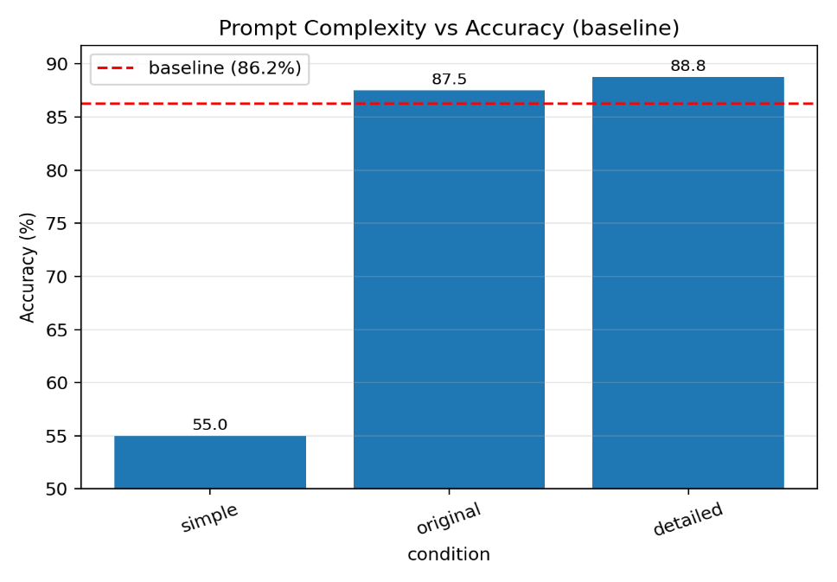
Here the effect is much stronger (Figure 2). The simple prompt loses over 30 percentage points compared with the original description, confirming that under-specified tasks drastically reduce correctness. Moving from original to detailed prompts yields only a small gain (about +1.25 points), indicating diminishing returns once the essential specification is already present.

3.4 Number of Demonstrations (Baseline)
Note that the k0 run here is implemented via the num_demos experiment pipeline and achieves 90.0% accuracy, which is slightly higher than the 86.25% default run in Section 3.1 due to minor differences in the prompt construction. Figure 3 plots baseline accuracy as a function of the number of demonstrations k.
As the number of demonstrations increases, baseline accuracy behaves non-monotonically:
- k0: 90.0%
- k1: 91.25%
- k2: 88.75%
- k4: 87.5%
Figure 3: Baseline pass@1 accuracy as a function of the number of demonstrations k
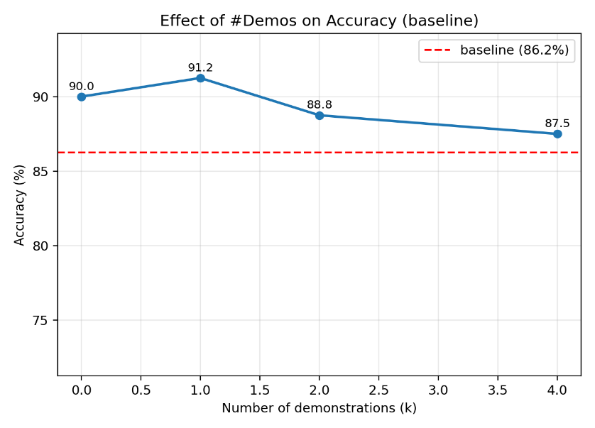
As illustrated by Figure 3, adding a single demo improves performance over zero-shot, but additional demos do not help further and even slightly hurt at k=2 and k=4. In other words, performance peaks around k = 1 and then slowly declines as more examples are added. A plausible explanation is that one or two examples are enough to align the model to the desired format, while longer prompts introduce distraction and increase the chance that the model copies irrelevant details.

3.5 Prompt Diversity (Baseline)
Figure 4 compares baseline accuracy for low and high prompt diversity. For prompt diversity, the baseline accuracy is:
- low: 90.0%
- high: 88.75%
Figure 4: Baseline accuracy for low vs high prompt diversity templates.
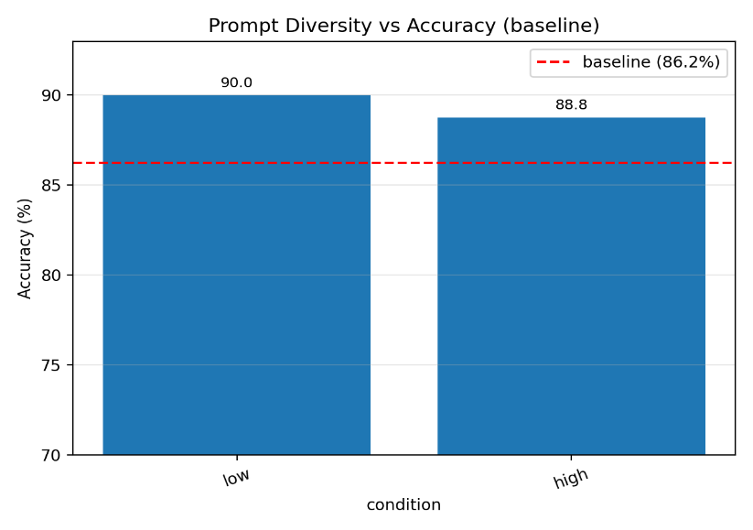
The effect is modest (Figure 4): high-diversity templates are about 1.25 points worse than a fixed template. This suggests that the model is already fairly robust to surface paraphrasing; structural factors like information content and examples matter more than phrasing.

3.6 Cross-dimensional summary (baseline)
Taken together, the baseline experiments show clear differences in how sensitive the model is to each prompt factor.
First, prompt complexity has by far the largest effect: moving from the original description to the simple variant reduces accuracy from 87.5% to 55.0%, a drop of more than 30 percentage points, whereas enriching the description only yields a marginal gain to 88.75%.
Second, the presence and quality of demonstrations mainly cause small, single-digit changes: using a wrong or irrelevant demo even slightly increases accuracy relative to the clean condition, and varying the number of demos from k = 0 to k = 4 only moves performance within a narrow band between 87.5% and 91.25%.
Third, prompt diversity has the weakest impact; switching from a fixed template to high-diversity templates changes accuracy by only about 1–2 points.
From an RQ1 perspective, these results suggest a clear ordering of importance for the baseline method: ensuring that the problem is fully specified (complexity) is crucial, while the exact phrasing (diversity) and even moderate demo noise matter much less. The number of demonstrations behaves more like a fine-tuning knob than a primary driver, with a shallow optimum around one example.

4 Combine Results and Comparison to Baseline

4.1 Overall Improvement
With the same default prompt, the combine method solves 73/80 tasks, reaching 91.25% pass@1—an absolute improvement of +5.0 percentage points over the baseline (Table 3).
Table 3: Default performance of baseline and combine on 80 HumanEval tasks.
Method | Tasks solved | Accuracy (%) | Avg exec time (s) | Avg prompt tokens | Avg completion tokens
Baseline | 69 / 80 | 86.25 | 0.48 | 169 | 53
Combine | 73 / 80 | 91.25 | 0.47 | 212 | 75
Interestingly, the average execution time per sample remains very similar (0.47 s vs. 0.48 s), although combine uses longer prompts (about 212 prompt tokens and 75 completion tokens on average). This shows that a lightweight repair loop can substantially increase reliability without a large runtime penalty, at the cost of extra token usage.

4.2 Prompt Quality: Baseline vs Combine
Figure 5 compares baseline and combine accuracy across the four prompt quality conditions. Across all four quality conditions, combine consistently outperforms the baseline:
- clean: 87.5 → 90.0% (+2.5)
- wrong_demo: 92.5 → 95.0% (+2.5)
- irrelevant_demo: 87.5 → 90.0% (+2.5)
- bad_instruction: 93.75 → 95.0% (+1.25)
Figure 5: Baseline vs combine accuracy across prompt quality conditions
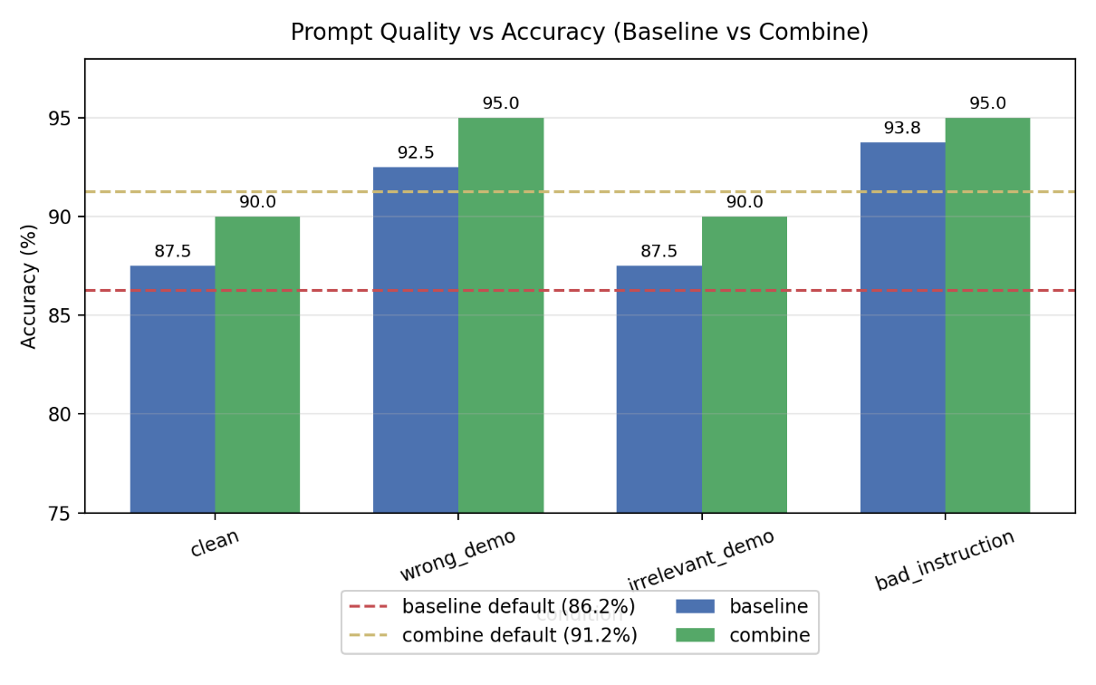
The gains are largest where prompts contain misleading demos or instructions. Even when the initial generation is influenced by noisy guidance, the repair phase can use failing tests to steer the code back toward correct behavior. This indicates that combine is more robust to prompt noise than a single-shot baseline.

4.3 Prompt Complexity: Baseline vs Combine
Figure 6 compares baseline and combine accuracy for different prompt complexity levels. For complexity, combine behaves slightly differently:
- simple: 55.0 → 53.75% (–1.25)
- original: 87.5 → 90.0% (+2.5)
- detailed: 88.75 → 91.25% (+2.5)
Figure 6: Baseline vs combine accuracy across prompt complexity levels
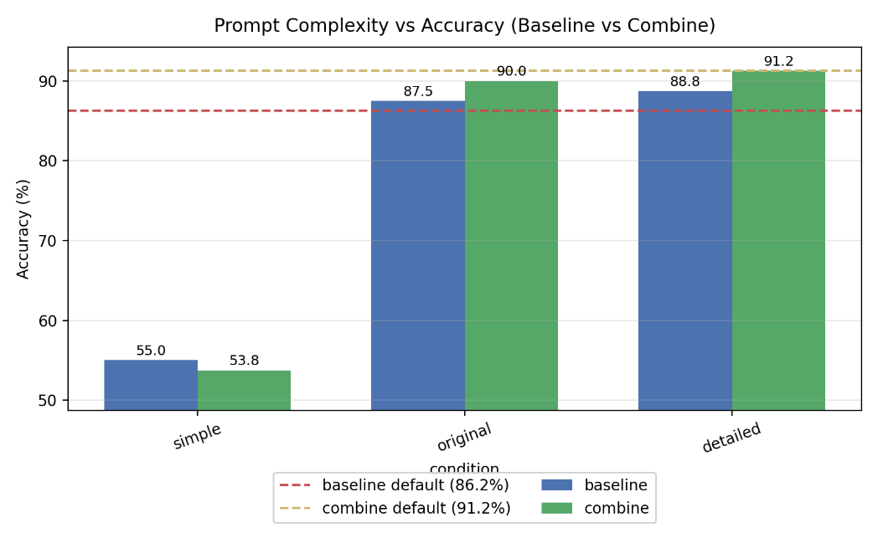
When the description is clear (original/detailed), combine provides consistent improvements of around 2.5 points, suggesting that self-correction can fix residual implementation bugs. However, when the problem is under-specified (simple), combine does not help: without enough information, the repair loop cannot infer the intended behavior from tests alone, and accuracy even drops slightly. This highlights a limitation of self-correction when the prompt itself is missing key constraints.

4.4 Number of Demonstrations: Baseline vs Combine
Figure 7 plots baseline and combine accuracy as a function of the number of demonstrations k. For the number of demonstrations, both methods show a shallow “sweet spot” but with different shapes:
- k0: 90.0 → 91.25% (+1.25)
- k1: 91.25 → 88.75% (–2.5)
- k2: 88.75 → 90.0% (+1.25)
- k4: 87.5 → 88.75% (+1.25)
Figure 7: Baseline vs combine accuracy as a function of the number of demonstrations k
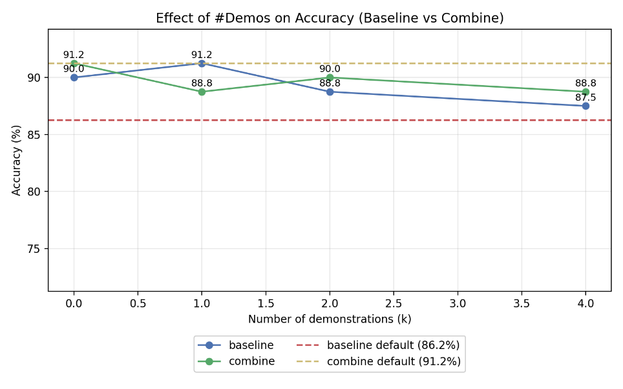
Combine generally improves over baseline at k0, k2 and k4, but performs worse at k1. The drop at k = 1 suggests that, for this specific configuration, the single demonstration already guides the baseline very well, and the repair loop can occasionally introduce regressions on top of an already strong first attempt. Overall, however, combine still reaches high accuracy across k, and the improvements at k0, k2 and k4 indicate that self-correction is complementary to few-shot prompting rather than a replacement.

4.5 Prompt Diversity: Baseline vs Combine
Figure 8 compares baseline and combine accuracy for low and high prompt diversity. For diversity, combine yields consistent but small improvements:
- low: 90.0 → 91.25% (+1.25)
- high: 88.75 → 90.0% (+1.25)
Figure 8: Baseline vs combine accuracy for low vs high prompt diversity
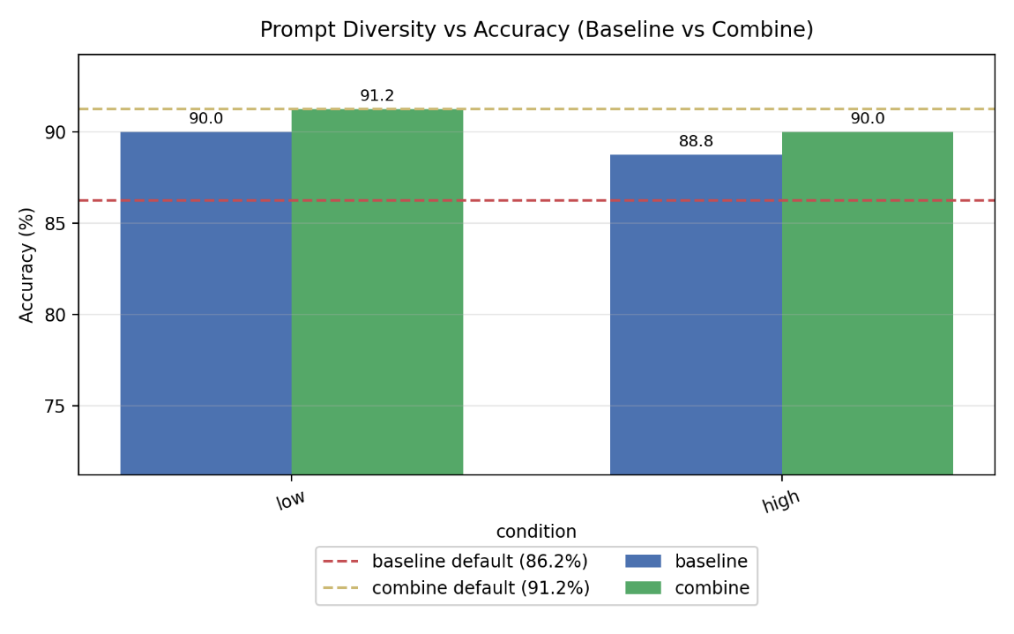
For diversity, combine yields consistent but small improvements (Figure 8). Both methods remain relatively insensitive to template diversity, and the combine–baseline gap is roughly constant. This reinforces the earlier conclusion that content (quality, complexity, examples) is more influential than surface style, while combine offers a fairly uniform boost independent of phrasing.

4.6 Where does combine help most?
The combine method does not improve all settings equally. It is most beneficial when the baseline is already given a reasonably well-specified task but still makes small implementation mistakes. For example, under the original and detailed prompts, combine consistently adds about 2.5 percentage points of accuracy on top of a strong baseline. Similarly, when there are zero, two or four demonstrations, combine reliably recovers 1–1.25 points over the baseline, and it also mitigates the harm of noisy demos or bad instructions in the quality experiments.
By contrast, combine fails to help—and can even slightly hurt—when the underlying task specification is too weak or when the baseline is already close to saturated. In the simple-complexity setting, accuracy remains around 55%, suggesting that no amount of test-driven repair can fully compensate for missing semantic information in the prompt. At k = 1, the baseline already performs very well, and the additional repair loop occasionally introduces regressions on top of a strong initial attempt.
From an RQ2 perspective, these patterns highlight that self-correction is best viewed as a robustness and polishing mechanism rather than as a substitute for good prompt design.

5 Discussion and Conclusion
Across all experiments, several patterns stand out:
- Specification quality dominates. Prompt complexity has the largest effect: moving from the original description to an overly simple one reduces baseline accuracy from 87.5% to 55.0%, and combine cannot fully recover from this. In contrast, “clean vs noisy” demos only change accuracy by a few points.
- Self-correction is effective but not magic. On the default prompt, combine improves accuracy from 86.25% to 91.25% without increasing execution time. It consistently helps for most prompt conditions, especially where the initial code is close but imperfect. However, when the prompt is fundamentally underspecified (simple) or already near-optimal (k=1 demos), the benefits are limited or even slightly negative.
- Prompt diversity is a secondary factor. Switching from low to high template diversity changes accuracy by roughly 1–2 points for both methods. This suggests that modern code LLMs are robust to moderate paraphrasing, and efforts are better spent on specifying the task clearly and designing good examples.
From a practical perspective, these findings suggest a simple prioritisation strategy for prompt and system designers. If only one factor can be improved, the first priority should be to upgrade simple, underspecified prompts to at least the original level of detail; this alone can recover more than 30 percentage points of accuracy. Given a reasonably clear description, adding one or two good demonstrations and enabling a lightweight self-correction pipeline (as in the combine method) are both worthwhile incremental steps. In contrast, investing effort in paraphrasing instructions or heavily tuning the number of demos beyond k = 1–2 is unlikely to yield comparable gains.
This study is limited to a single benchmark (HumanEval) and one model, and I only measure pass@1 and runtime. In future work, it would be interesting to repeat the analysis on other code benchmarks, with larger models and alternative self-correction algorithms, and to evaluate additional aspects such as code readability or security. Nevertheless, the current results already indicate that careful prompt design, combined with a lightweight repair pipeline, can significantly improve the reliability of LLM-based code generation in a practical and easily implementable way.

Appendix A. Example Prompts and Demonstrations
This appendix provides concrete examples of the prompts used in the experiments, illustrating how different conditions were instantiated in practice.

A.1 Default baseline prompt (clean, original, k = 0)
The following example shows the default baseline prompt for a hypothetical HumanEval-style task that checks whether a string is a palindrome. In the actual experiments, the problem text is taken from the original HumanEval JSON file, but the structure of the prompt is the same.
- System message
You are an expert Python developer.
- User message
请根据以下描述实现一个完整的Python函数：

Write a function `is_palindrome(s: str) -> bool` that returns True if and only if
`s` reads the same forward and backward. The function should ignore spaces and
be case-insensitive. For example:
- is_palindrome("racecar") == True
- is_palindrome("Race Car") == True
- is_palindrome("abc") == False

⚠️请仅输出完整的函数定义（以 def 开头），不要解释或添加注释。
This corresponds to the clean, original and k = 0 setting for the baseline and combine methods: there is no demonstration, and the description is neither simplified nor deliberately corrupted.

A.2 Prompt with an intentionally wrong demonstration (quality = wrong_demo)
The next example illustrates the “wrong_demo” condition in the prompt-quality experiments. Here, I first show an example task and a deliberately incorrect solution, and then ask the model to ignore that implementation and write a correct one for the target task.
- System message
You are an expert Python developer.
- User message
下面是一个示例任务及其解答（注意：示例实现是故意写错的，只用于展示格式）：

【示例题目】
Write a function `sum_list(xs: List[int]) -> int` that returns the sum of all integers in the list.

【错误示例代码】
def sum_list(xs: List[int]) -> int:
# Intentionally wrong demo implementation
return 0

现在请你忽略上述错误实现，仅将其作为格式参考。
请为下面的正式任务重新编写**正确**的 Python 函数实现：

Write a function `is_palindrome(s: str) -> bool` that returns True if and only if
`s` reads the same forward and backward, ignoring spaces and case.

⚠️请仅输出完整的函数定义（以 def 开头），不要解释或添加注释。
In the actual experiments, the “示例题目” and the incorrect code are derived automatically from another HumanEval problem using the same pattern, but the overall structure—one wrong demonstration followed by the true target task—is consistent with this example.

